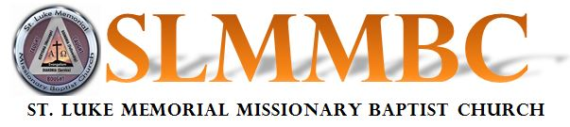
SCHOLARSHIP APPLICATION
Deadline: Last Sunday in July and December Submit to: Pam Dickens or Dari Ragland
Email to: dari57@yahoo.com
GUIDELINES
- Applicant must be an active member of the St. Luke Memorial Missionary Baptist Church
- All applicants must be attending a college/university or trade school
- First priority will go to graduating high school seniors
- Applicant must submit a copy of their class schedule for the current semester for proof of enrollment
- Applicant must submit application and documentation by deadline
Applicant’s Name
Click or tap here to enter text.
Home Address
Click or tap here to enter text.
City | State | Zip Code | Home Telephone
Click or tap here to enter text. | Click or tap here to enter text. | Click or tap here to enter text. | Click or tap here to enter text.
Parent’s Name(s)
Click or tap here to enter text.
Applicant’s Email Address
Click or tap here to enter text.

School Attending
Click or tap here to enter text.
Applicant’s School Address |  |  | Apt/Dorm Room #
Click or tap here to enter text. |  |  | Click or tap here to enter text.
City | State | Zip Code |  | Cell Phone Number
Click or tap here to enter text. | Click or tap here to enter text. | Click or tap here to enter text. |  | Click or tap here to enter text.

Year in School  Click or tap here to enter text. | ☐ Freshman / 1st Year ☐ Sophomore / 2nd Year ☐ Junior ☐ Senior ☐ Post Graduate
Major
Click or tap here to enter text.

Church Information (List auxiliary or ministries that you are a member of)
Click or tap here to enter text. | Click or tap here to enter text.
Click or tap here to enter text. | Click or tap here to enter text.
Click or tap here to enter text. | Click or tap here to enter text.

Please see Bro. Duane McLemore to have your picture taken.

